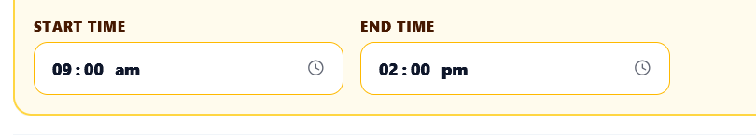
1.
Update the JCB Rental form UI. In the “SELECT JCB MACHINE” section, remove the “START TIME” and “END TIME” fields completely. They are not required. Keep only a single “QTY” field for the rental quantity. Do not add any time-related fields or functionality.

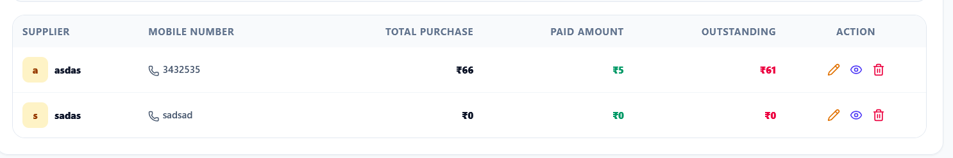

2.Implement the Supplier Detail page/navigation exactly like the existing Customer Detail page.
When the user clicks on any supplier in the Supplier List, it should navigate to a dedicated Supplier Details page, just like clicking a customer opens the Customer Details page.

3. pdate the Supplier WhatsApp message behavior.
When the user clicks the WhatsApp button on the Supplier Details page, the WhatsApp message must NOT include the driver's name anywhere.
4. Update the Finance module to use Compound Interest instead of Simple Interest.
The Finance/Loan calculation logic must be changed from simple interest to compound interest throughout the application.

5. Fix the delete functionality in the Finance → Loan and Return Ledger.
Currently, when I delete a Loan or Return Ledger entry, it appears to be deleted temporarily, but after refreshing the page or reopening the Finance module, the same entry appears again.
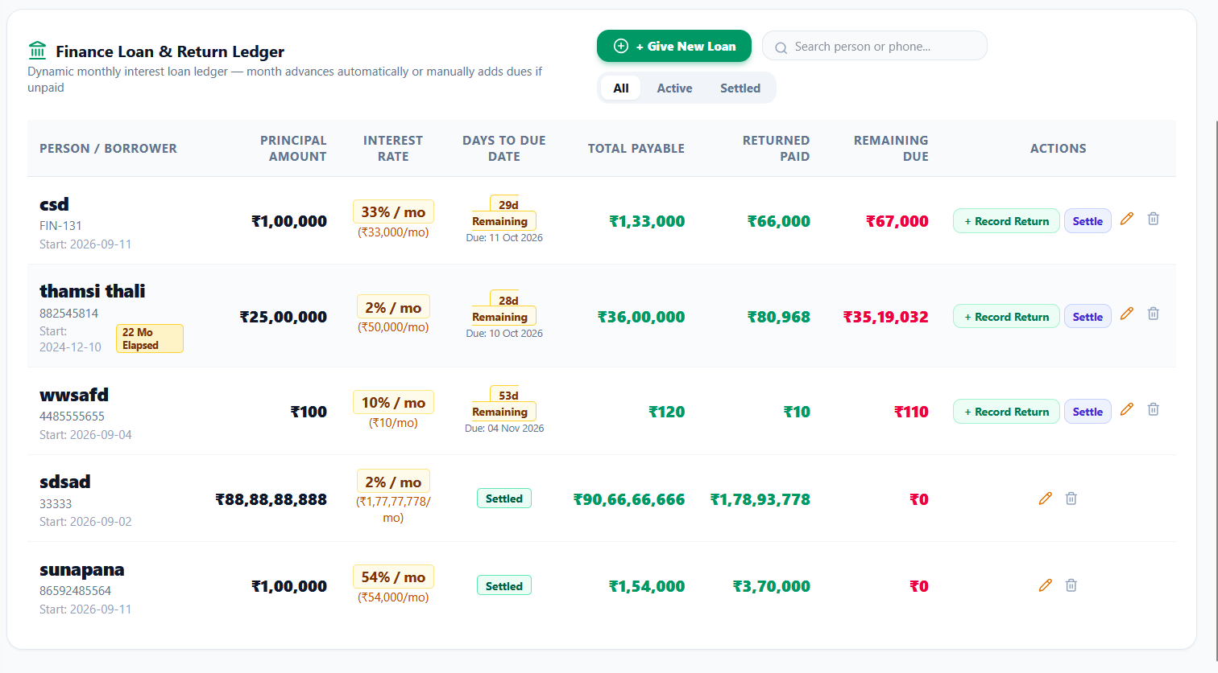

6. Add an Edit ✏️ option to the Finance → Loan & Return Ledger. Clicking Edit should open the existing transaction form with values pre-filled. Save changes to the database, prevent duplicate records, refresh the ledger, and recalculate compound interest and outstanding balances affected by the edit. Keep the existing UI/design unchanged.

7.In the Choose Customer dropdown, add a Search Customer input at the top. Users should be able to type a name or mobile number to quickly filter and find customers. Keep the existing dropdown design and “+ Add New Customer” option unchanged.

8.Fix the Expenses module — expenses are not saving at all.
When I fill in an expense and click Save Expenses, the expense must be successfully saved to the backend/database and then immediately appear in the Expenses/Transactions list.
9.In the JCB Rental Log table, update the Item / Service Details section to also display the JCB Number and Driver Name for each rental entry.
Example:
JCB Earthmoving
JCB No: JCB-01
Driver: Driver Name
Fetch these values dynamically from the corresponding JCB rental record. Do not hardcode them, and keep the existing table design and layout unchanged.
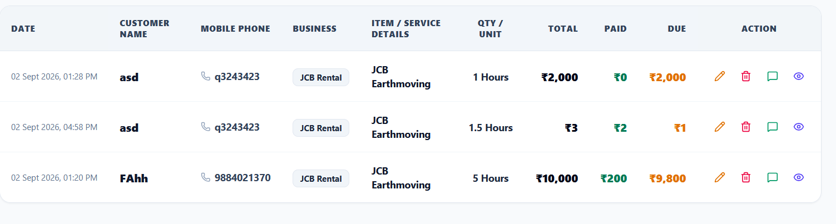

10.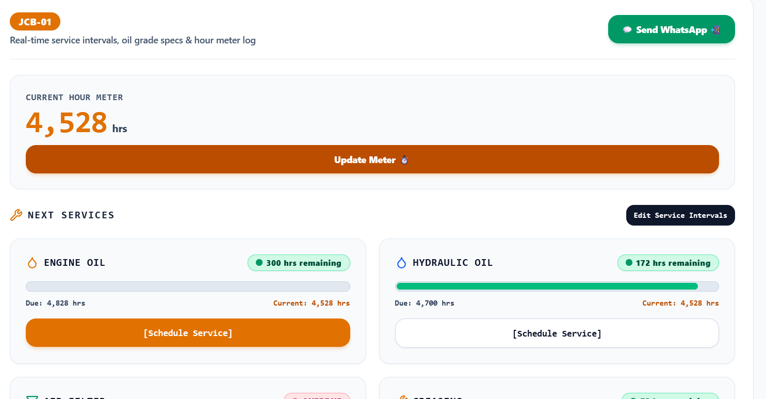
Make the JCB Hour Meter JCB-specific.
Each JCB must have its own independent hour meter.
- Initially, every JCB starts at 0 hrs.
- If JCB-01 has a rental of 5 hrs → JCB-01 meter becomes 5 hrs.
- If JCB-02 has a rental of 3 hrs → JCB-02 meter becomes 3 hrs.
- Adding hours to JCB-01 must not affect JCB-02 or any other JCB.
- Calculate each JCB's meter only from its own rental entries using the JCB ID/number.
- Editing or deleting a rental entry should recalculate only that JCB's meter.
- The dashboard, service intervals, remaining hours, and progress bars must use the selected JCB's individual meter.
- Persist the values correctly in the database and keep them after refresh.

